**ASSIGNMENT-1**

## ***#Create an account on aws and launch instance:-***

## 1- Create an Amazon Web Services root or IAM user account.

## 2-Open ec2 services, then instances, and finally the Mumbai, Asia region.

## 3- Give your instance a name, then select it by clicking on the window OS.

## 4-Select the kind of instance (t3.micro). Now, create a name for your key pair (the format should be .pem or .ppk depending on your needs, and the key pair type should beRSA).

## 5-After you generate your key, it will be downloaded immediately.

## 6- If you want to send SSH traffic from anywhere on the internet, use 0.0.0.0/0 or my IP address.

## 7-Now press the “launch instance” button.

## 8-After your instances have been launched, navigate to them and select your instance.

## 9-Choose “connect,” then “RDP client,” and then “download.”

## 10-Now, select Get Password followed by Upload Private Key.

## 11-Then choose and upload your .pem or . ppk file.

## 12-Then click the decrypt password button and copy your password.

## 13-Open your remote desktop file, paste your password, and then click the “Connect Now button”. Your virtual window will now be open and ready for usage.

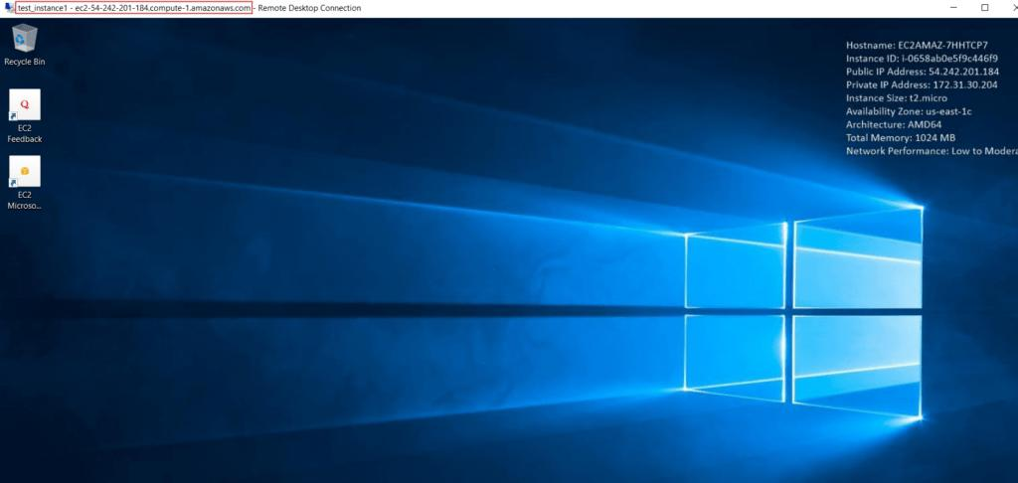

***#Install web server:-***

1-You must now run a web browser in to install Apache static web server to host static web pages on the internet.

2-Simply search for Apache web server and choose your preferred file from the list of results.

3-The file should then be extracted to the C disk using file explorer.

4- After extracting the file, open it and copy the path to the bin folder. Start the administrator’s command Prompt now.

5-Now type cd, which stands for change directory.

6- cd c:Apache24bin, then httpd -k install, and apache is now up and running.

7-To test it, launch your web browser and enter 127.0.0.1 into the address box.

8-If everything is in order, you should be able to see the “it works!” web page in your browser locally.

